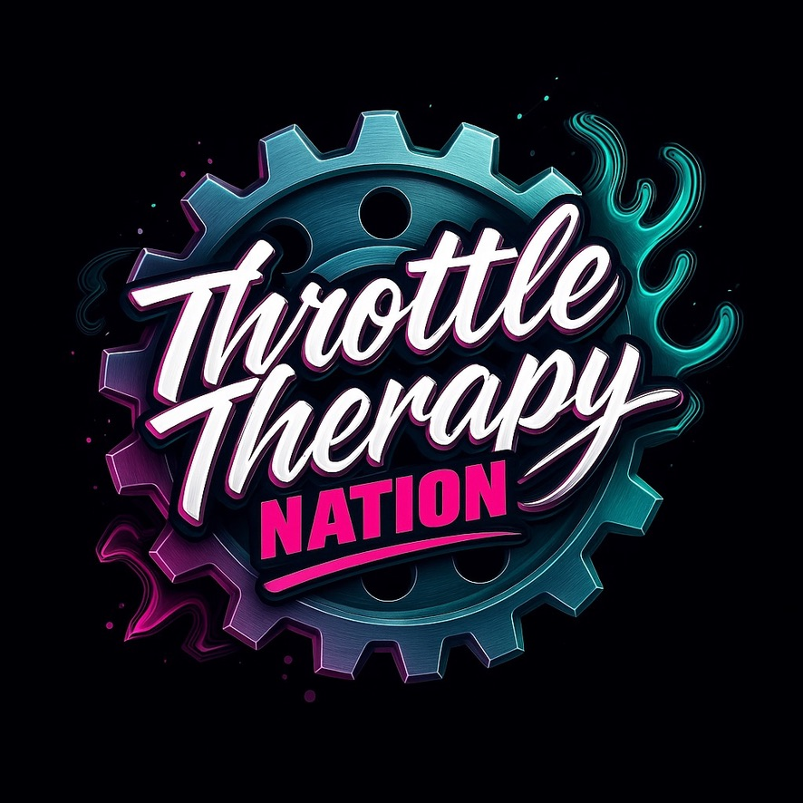
Throttle Therapy Nation™
Riders Education Module Series
Your guided pathway into the TTN full-length rider education book
Beyond the Wheel: SxS Ownership Essentials™
Sneak peek edition — full book launches later this year.
Bentley GOALs Offroad

Module Series Summary
This Education Module Series represents the complete TTN™ Education System — a unified, national-standard rider
education program designed for new riders, families, ride leaders, parks, trail systems, brands, builders, and educators.
The chapters are structured across four lanes to guide every type of rider, partner, or industry professional through
a clear, safe, and deeply informed progression.
Lane One builds the foundation for new riders, youth, families, and machine ownership.
Lane Two empowers ride leaders and crew chiefs with structure, planning, etiquette, and post-ride responsibilities.
Lane Three equips parks and trail systems with clarity, safety communication, and world‑class rider guidance.
Lane Four unifies brands, builders, educators, and TTN into a single safety and culture messaging system.
This book is the cornerstone of TTN’s mission:
Ride. Heal. Belong.

TABLE OF CONTENTS

Chapter 2 — Riding With Kids & Families
Chapter 3 — Machine Ownership 101
Chapter 4 — Pre‑Ride Planning
Chapter 5 — Trail Etiquette 101
Chapter 6 — After‑Action Checks
Chapter 7 — Trail Clarity & Ratings
Chapter 8 — On‑Site Education Touchpoints
Chapter 9 — Unity Messaging (Parks)
Chapter 10 — Safety Sheets
Chapter 11 — Unity Messaging (Brands & Builders)
Chapter 12 — Co‑Branded Education

A Letter From the Founder
To the Riders, Families, Builders, Educators, Parks, and Every Member of This Nation,
Throttle Therapy Nation™ was never meant to be just another off‑road brand. It was born from real riders, real moments, and a real belief that the throttle can change lives. What began as a personal escape — a place to breathe, reset, and reconnect — has grown into a movement that spans machines, terrain, generations, and communities across the country.
You are holding the heart of that movement in your hands.
This book was created to guide new riders, empower families, elevate ride leaders, support parks, unify brands and builders, and protect the future of our sport. Every chapter carries the message we live by: Ride. Heal. Belong.
Because riding isn’t just something we do — it’s where many of us learn who we are.
It’s where we bring our kids and build the next generation of safe, confident riders.
It’s where we meet strangers who become trail family.
It’s where we find clarity, courage, and connection in a world that often feels chaotic.
The TTN Education System exists because you deserve more than “figure it out as you go.”
You deserve guidance, safety, mentorship, and a clear pathway to growth — no matter your experience level.
To every park working to become the Gold Standard, every builder putting safety first, every brand choosing clarity over hype, every educator stepping up, every parent teaching their child, and every rider trying to do it the right way: thank you.
You are the reason TTN exists.
This movement belongs to all of us. Together, we are building something that will outlive trends, machines, and even generations — a riding culture rooted in respect, unity, and responsibility.
Welcome to Throttle Therapy Nation™.
Welcome to the next chapter of your journey.
With purpose and gratitude,
Mercedes N. Bentley
Founder & CEO
Throttle Therapy Nation™

Coming Soon: Beyond the Wheel™
For riders who want the full deep-dive experience, an even more powerful resource is on the horizon.
The TTN™ Education System you’ve just read is only the beginning. Soon, we will release the complete, immersive guide:
**Beyond the Wheel: SxS Ownership Essentials™**
This book expands every principle you’ve learned here with:
• Step-by-step ownership mastery
• Detailed maintenance walkthroughs
• Real-world troubleshooting scenarios
• Upgrade sequencing and machine setup logic
• Safety systems, family guidance, and terrain adaptation
• A true rider-to-rider mentorship experience in written form
If the throttle is where you find clarity —
If the trail is where you feel alive —
If the machine is part of your identity —
Then *Beyond the Wheel* will become your go-to companion.
**Stay tuned. The next evolution of TTN™ rider education is on the way.**
How to Use This Education Module Series
This Education Module Series is designed to guide riders, families, parks, builders, and industry partners
through the foundational principles of safe, confident, and responsible off‑road riding. Each chapter represents
a portion of the full-length book *Beyond the Wheel: SxS Ownership Essentials™*, and is structured to provide
immediately usable knowledge while previewing the deeper content coming in the full release.
Here’s how to get the most from this series:
1. **Read in Order**
Each chapter builds on the previous one. Begin at Chapter 1 and move forward for a smooth, structured progression
from beginner basics to advanced park, builder, and industry‑level systems.
2. **Use as a Training Tool**
These modules are designed for:
• New rider introductions
• Family education sessions
• Ride leader preparation
• Park staff training
• Builder and shop onboarding
• Brand partnerships and safety communication
3. **Apply the Concepts on Every Ride**
The goal is not just reading — it’s transformation.
Practice the checklists, pre‑ride steps, etiquette rules, and communication standards on your next ride.
4. **Share With Your Group or Community**
Riding is safer and more enjoyable when everyone operates with the same expectations.
Use these modules as conversation starters for your crew, park visitors, or customer base.
5. **Prepare for the Full Book Release**
This series contains approximately 20–30% of the depth you will receive in the complete *Beyond the Wheel* book.
The full edition will include:
• Advanced diagnostics
• Terrain‑specific strategies
• Machine setup logic
• Deep‑dive rider development
• Expanded leadership training
• Family riding mastery
• Youth progression systems
6. **Return to Modules Frequently**
As your skills grow, the meaning of each chapter grows with you. What feels basic today will reveal deeper nuance
after 10, 20, or 100 rides.
7. **Integrate With TTN™ Systems**
Use this module series alongside:
• TTN Rider Education Center
• TTN Park & Trail Clarity Foundation
• Axle & Arc Fab safety + installation guides
• TTN brand partnership resources
These modules are one piece of a nationwide shift toward safer, smarter, unified riding.
---
This is your roadmap.
Your head start.
Your first step into a much larger world of off‑road mastery.
Welcome to the TTN Education Module Series.

Who This Series Is For
The TTN Education Module Series is designed for every type of rider and partner in the off-road community.
Whether you are brand new, deeply experienced, or a professional within the industry, these modules provide the clarity,
structure, and guidance needed to elevate your safety, confidence, and leadership.
This series is especially valuable for:
• New Riders — learning foundations and expectations
• Families — ensuring children ride safely with proper preparation
• Ride Leaders & Crew Chiefs — structuring pre‑ride, on‑trail, and post‑ride responsibilities
• Parks & Trail Systems — improving clarity, signage, ratings, and guest education
• Builders & Shops — unifying customer messaging and safety communication
• Brands — aligning safety sheets, product guidance, and industry stewardship
• Educators — teaching with a consistent national standard
If you touch a throttle — or teach someone who does — this series is built for you.

About Throttle Therapy Nation™
Throttle Therapy Nation™ is a nationwide movement dedicated to building safer, smarter, more unified riders
across every terrain and every throttle-powered platform. TTN was founded on the belief that riding is more than
a hobby — it is healing, connection, adrenaline, clarity, and community.
Our mission is simple:
Ride. Heal. Belong.
TTN exists to:
• Empower riders through education
• Protect families and young riders
• Support parks in becoming the Gold Standard
• Elevate builders and brands with unified messaging
• Create clarity through mapping, training, and communication
• Build a national culture of safety and respect
We are riders. We are educators. We are innovators.
And this module series is one of the foundational pillars of the TTN movement.

Lane One: New Riders & Families
–––––––––––––––––––––––––––––––
A TTN™ Education Module
A dedicated educational lane within the TTN Module Series.

Lane Two: Ride Leaders & Crew Chiefs
–––––––––––––––––––––––––––––––
A TTN™ Education Module
A dedicated educational lane within the TTN Module Series.

Lane Three: Parks & Trail Systems
–––––––––––––––––––––––––––––––
A TTN™ Education Module
A dedicated educational lane within the TTN Module Series.

Lane Four: Brands, Builders & Educators
–––––––––––––––––––––––––––––––
A TTN™ Education Module
A dedicated educational lane within the TTN Module Series.
Chapter 1 – New Rider Basics
––––––––––––––––––––––––––––––––
■■■■■■■■■■■■■■■■■■■■■■■■■■■■■■

Lane Four: Brands, Builders & Educators

CHAPTER 10 — SAFETY SHEETS
Safety Sheets are the rider’s first line of defense against misuse, misunderstanding, and preventable injury. They are the clearest, simplest, and most accessible way a brand, builder, or educator can communicate life‑saving information before a rider ever starts the engine. Safety Sheets are not paperwork—they are protection.
1. The Purpose of Safety Sheets
A great Safety Sheet:
• Prevents installation errors
• Reduces accidents
• Reduces warranty claims
• Protects children and passengers
• Improves product longevity
• Builds trust between brand and rider
Safety begins with clarity.
2. The Six Types of Safety Sheets
Every brand or builder should produce:
• Installation Safety Sheets
• Operational Safety Sheets
• Maintenance Safety Sheets
• Terrain-Specific Safety Sheets
• Skill-Level Safety Sheets
• Youth & Passenger Safety Sheets
Each sheet plays a unique role in the education ecosystem.
3. Installation Safety Sheets
Improper installation is one of the leading causes of injury and machine failure.
Sheets must include:
• Tools required
• Torque specifications
• Diagrams
• “Stop and verify” points
• Common mistakes
• Photos of correct vs incorrect install
Clarity prevents catastrophic outcomes.
4. Operational Safety Sheets
These sheets explain how a part changes machine behavior.
Include:
• Handling changes
• Power changes
• Traction differences
• Braking adjustments
• New risks introduced
Riders do not always understand how upgrades affect capability.
5. Maintenance Safety Sheets
Maintenance is the most overlooked aspect of safe riding.
Include:
• Service intervals
• Lubrication points
• Cleaning instructions
• Wear indicators
• When to replace parts
A rider cannot protect what they do not inspect.
6. Terrain-Specific Safety Sheets
Terrain affects how parts behave.
Explain:
• Rock crawling stress points
• Sand heat load
• Mud contamination risks
• Water intrusion hazards
• Off-camber limitations
Terrain education prevents misuse.
7. Skill-Level Safety Sheets
Upgrades require matching skill levels.
Sheets should state:
• Beginner-friendly
• Intermediate recommended
• Expert required
• Professional installation required
Skill mismatches cause accidents.
8. Youth & Passenger Safety Sheets
Children require specialized safety education.
Include:
• Harness geometry
• Seat fitment
• Age recommendations
• Passenger limitations
• Smooth-driving guidance
Kids rely fully on adults to protect them.
9. QR Code Integration
Modern Safety Sheets MUST include QR links to:
• Install videos
• Maintenance tutorials
• TTN Education resources
• Terrain guides
• FAQ pages
QR = clarity at scale.
10. Tone & Formatting Best Practices
Safety Sheets should be:
• Visual
• Simple
• Direct
• Honest
• Non‑technical when possible
Use diagrams, photos, icons, and bullet points.
11. Real‑World Scenarios
Scenario 1: Incorrect harness installation → ejection risk
Scenario 2: Oversized tires without clutching → belt failure
Scenario 3: Tune without understanding heat load → engine damage
Scenario 4: Rear seats added without guidance → unsafe harness angles
Safety Sheets prevent all of these.
12. The TTN™ Standard
The TTN‑approved Safety Sheet includes:
• Purpose
• Warnings
• Step-by-step clarity
• Fitment details
• Installation checks
• Maintenance schedule
• Terrain notes
• Youth considerations
• QR code extensions
Education saves lives.
13. The Path Forward
Safety Sheets are the bridge between the industry and the rider. When brands adopt standardized Safety Sheets, the off-road community becomes safer, smarter, and more united across every platform from dirt to desert.
This chapter opens Lane Four, preparing the industry for the cultural and collaborative systems that follow.

Chapter 11 – Unity Messaging (Brands)
––––––––––––––––––––––––––––––––
■■■■■■■■■■■■■■■■■■■■■■■■■■■■■■
CHAPTER 11 — UNITY MESSAGING (BRANDS & BUILDERS)
Unity Messaging for brands and builders is the national-standard communication framework that aligns product creators, installers, educators, and riders under one purpose: safer, smarter, more confident off-road communities. It is how the industry speaks with one voice.
1. Why Brand Unity Messaging Matters
When messaging is inconsistent:
• Riders misuse products
• Installers make assumptions
• Safety sheets are ignored
• Miscommunication spreads online
• Younger riders receive conflicting information
Unity Messaging eliminates confusion.
2. The Three Audiences of Brand Messaging
Every brand must clearly communicate with:
• The customer
• The installer/builder
• The educator or partner
Each group requires tailored clarity.
3. Safety-Focused Messaging
Brand messaging should emphasize:
• Proper installation
• Terrain limitations
• Skill-level recommendations
• Rider responsibilities
• Passenger safety
Safety must be present in every conversation.
4. Product Capability Messaging
Riders must understand what a product CAN and CANNOT do.
Messaging includes:
• Intended use
• Compatibility
• Limitations
• Required upgrades
• Maintenance expectations
Clear expectations prevent misuse.
5. Upgrade Pathway Messaging
Riders often purchase parts in the wrong order.
Builders should guide:
SAFETY → PROTECTION → RELIABILITY → PERFORMANCE → COSMETICS
This structure protects the rider and the machine.
6. Terrain & Use-Case Messaging
Different riders require different products.
Brands should provide guidance for:
• Mountain riding
• Mud riders
• Sand dunes
• Rock crawlers
• Trail explorers
• Youth/family riders
The product must match the environment.
7. Skill-Level Messaging
Parts should state:
• Beginner-friendly
• Intermediate recommended
• Expert-only
• Professional installation required
Skill mismatches lead to preventable accidents.
8. Build Shop & Installer Messaging
Builders must reinforce:
• Correct torque specs
• Safe routing of wires and hoses
• Harness geometry
• Suspension tuning basics
• Post-install inspection steps
Messaging from shop to customer must be standardized.
9. Rider Education Messaging
Brands should integrate:
• QR codes to tutorials
• Links to TTN Education Center
• Video walkthroughs
• Maintenance intervals
• Upgrade recommendations
Education extends beyond the sale.
10. Co-Branded Messaging with Parks
Brands and parks can unify messaging:
• Safety rules
• Terrain suitability
• Family riding guidance
• Weather impact warnings
Partnerships amplify clarity.
11. Community-Culture Messaging
Brands influence rider culture.
Messaging should promote:
• Respect
• Safety
• Inclusivity
• Responsible riding
• Youth protection
• Environmental stewardship
Culture spreads through communication.
12. Post-Sale Messaging
After purchase, brands should send:
• Safety reminders
• Maintenance tips
• Accessory recommendations
• Terrain-use guides
• Customer support touchpoints
Support builds loyalty.
13. Influencer Alignment
Influencers must:
• Demonstrate safe riding
• Follow helmet rules
• Avoid glorifying dangerous behavior
• Reinforce skill-appropriate usage
• Model correct etiquette
Brand partners reflect brand values.
14. The Tone of Unity Messaging
Tone must be:
• Clear
• Supportive
• Educational
• Honest
• Integrity-driven
Tone shapes trust.
15. Real-World Scenarios
Scenario 1: Customer installs harnesses incorrectly
Solution: clearer installation messaging
Scenario 2: Beginners buy expert-level tunes
Solution: skill-matched upgrade messaging
Scenario 3: Builders install wiring unsafely
Solution: standardized shop procedures
16. Preventing Online Confusion
Brands should reduce misinformation by:
• Providing official FAQs
• Posting video tutorials
• Engaging respectfully with customers
• Correcting unsafe myths
Clear messaging protects riders everywhere.
17. The TTN™ Unified Messaging Framework
TTN provides:
• Templates
• Safety sheets
• Co-branded education
• Installer training
• Park integration
• Product-specific guidance
Unity becomes national.
18. The Role of Builders in Messaging
Builders must:
• Ensure customer understanding
• Demonstrate safety basics
• Review harness geometry
• Test machines before release
• Provide post-build care sheets
Builders shape rider confidence.
19. The Responsibility of Brands
Brands must:
• Teach
• Warn
• Guide
• Explain
• Support
Messaging is responsibility in written form.
20. The Path Forward
Unity Messaging for Brands & Builders forms the industry layer of the TTN Education System. When brands, parks, builders, and riders all speak the same language, safety becomes culture—not instruction.
This chapter prepares the foundation for Chapter 12: Co-Branded Education and the future of national unity in rider safety.
––––––––––––––––––––––––––––––––
■■■■■■■■■■■■■■■■■■■■■■■■■■■■■■
CHAPTER 12 — CO‑BRANDED EDUCATION
Co‑Branded Education is the future of the off-road community. It is where parks, brands, builders, educators, and TTN come together to deliver the clearest, safest, most unified rider education ever created in the powersports world. This chapter outlines how industry partners align their voices, products, safety systems, and messaging to protect riders and elevate the sport.
1. Why Co‑Branded Education Matters
When education is fragmented:
• Riders receive mixed messages
• Installers assume customers “already know”
• Parks struggle to keep guests safe
• Brands face preventable failures
• Families lose confidence in the sport
Co‑Branded Education eliminates confusion and increases safety across the entire ecosystem.
2. What Co‑Branded Education Includes
A complete co‑branded educational system contains:
• Safety Sheets
• Installation videos
• Terrain‑specific guidance
• Youth and family recommendations
• Digital mapping clarity
• Skill‑level pathways
• Unified etiquette messaging
• QR-driven resource hubs
Education becomes predictable, consistent, and accessible anywhere riders go.
3. The Three Pillars of Co‑Branded Education
Pillar 1 — Clarity
Pillar 2 — Consistency
Pillar 3 — Collaboration
Every partner speaks the same language.
4. How TTN Integrates With Brands
TTN provides:
• Standardized safety templates
• Unified terminology
• Skill-level definitions
• Youth‑safety guidelines
• Terrain‑suitability charts
• Video integration opportunities
Brands gain a national educational backbone.
5. How TTN Integrates With Builders
Builders are the frontline educators.
TTN helps builders:
• Explain install risks
• Provide post‑build safety sheets
• Deliver maintenance schedules
• Offer rider skill evaluation tools
• Promote family‑first safety
Builders become trusted partners in rider education.
6. How TTN Integrates With Parks
Parks use co‑branded materials to:
• Educate visitors
• Reduce rescue calls
• Improve trail flow
• Support youth riders
• Clarify terrain difficulty
• Reinforce etiquette
Parks become safer and more inclusive through shared messaging.
7. The Co‑Branded Safety Sheet System
Each safety sheet features:
• Brand logo
• TTN safety approval mark
• Clear warnings
• Installation notes
• Skill‑level recommendations
• Terrain compatibility
• Maintenance requirements
• QR links to deeper education
Riders receive unmatched clarity.
8. Unified Rider Pathway Messaging
Co‑branded education ensures every rider understands:
• Where to start
• How to progress
• Which upgrades match their skill level
• When to seek training
• How to ride with youth safely
This prevents dangerous “jumping ahead.”
9. QR Integration Across All Partners
QR codes connect riders to:
• Safety videos
• Terrain guides
• TTN knowledge base
• Park rules
• Product-specific tutorials
• Family safety resources
QR creates a living, evolving educational network.
10. Co‑Branded Digital Mapping Integration
Digital maps gain:
• Brand-supported safety notes
• Builder‑recommended routing
• Park‑verified trail clarity
• TTN color‑coded standards
Mapping becomes a shared platform.
11. Social Media Alignment
Partners reinforce unity by:
• Demonstrating safe behavior
• Promoting family‑friendly practices
• Explaining products with honesty
• Highlighting youth safety
• Modeling etiquette
Partners lead by example.
12. Event & Ride Integration
Co‑branded education appears at:
• Guided rides
• Safety clinics
• Youth rider days
• Product demo events
• Park festivals
Events become educational—not just entertainment.
13. Influencer Alignment
Influencers carry immense cultural power.
They must:
• Model helmet use
• Avoid reckless content
• Demonstrate proper harnessing
• Promote youth-safe practices
• Teach basics in their videos
Co‑branded guidelines create consistency.
14. How Co‑Branding Protects Riders
Riders benefit through:
• Clearer instructions
• Better installation outcomes
• Fewer mechanical failures
• Safer terrain decisions
• More consistent upgrades
• A stronger riding community
Education equals prevention.
15. How Co‑Branding Benefits Brands
Brands gain:
• Fewer warranty claims
• Higher customer trust
• Better product longevity
• Stronger brand loyalty
• Increased exposure through TTN and parks
• A reputation for responsibility
Safety is good business.
16. How Co‑Branding Benefits Builders
Builders gain:
• Unified install documentation
• Fewer customer errors
• Stronger trust from riders
• Expanded clientele through TTN
• Reputation as elite educators
Builders become leaders.
17. How Co‑Branding Benefits Parks
Parks gain:
• Fewer accidents
• Happier families
• Better rider flow
• Improved trail life
• National recognition
Parks become educational ecosystems.
18. The TTN National Standard Vision
The future includes:
• Nationally standardized trail ratings
• Unified safety sheets
• QR-linked knowledge networks
• Educator certification programs
• Youth & family riding programs
• Industry-wide cultural messaging
This is the Gold Standard.
19. How Partners Join the TTN Co‑Branded Program
Partners complete:
• Messaging alignment
• Safety sheet integration
• Install/operation review
• Digital mapping sync
• Staff education
• Asset approval
The system is turnkey and scalable.
20. The Path Forward
Co‑Branded Education is the final chapter because it represents the summit of the TTN ecosystem.
It connects:
• Riders
• Families
• Builders
• Brands
• Parks
• Educators
All speaking one language.
All moving toward one goal.
All building a safer, smarter, stronger riding nation.
This chapter completes the TTN Education System and establishes the framework for national unity in off‑road safety and culture.
Chapter 12 – Co-Branded Education
Full chapter text will be inserted upon request.

